BIOS&EC Upgrade guide

一, Format the usb flash disk to fat32 file format;

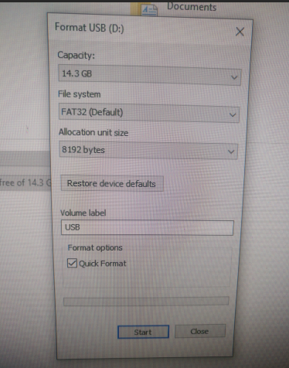

二. Unzip the folder, And copy all files to the root directory of the usb flash disk;

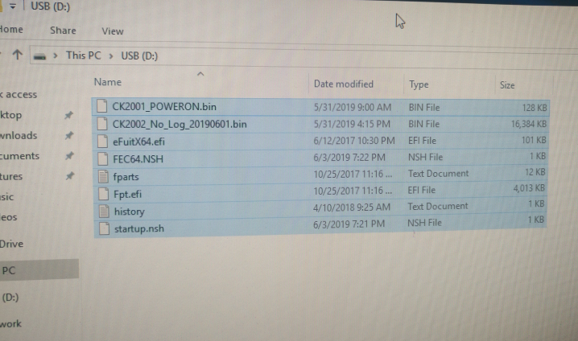

1. Insert the USB flash disk into the USB port of the device,Then power on the device;

四．Keep pressing F7 key on the keyboard during the boot running, The device will be into boot menu, Then Select "UEFI: SanDisk, Partition 1" to enter

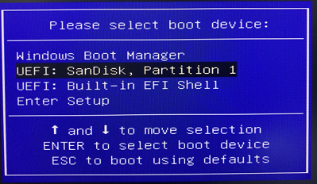

五．the update will automatically until tips for successful

a. BIOS update is successful as  following:

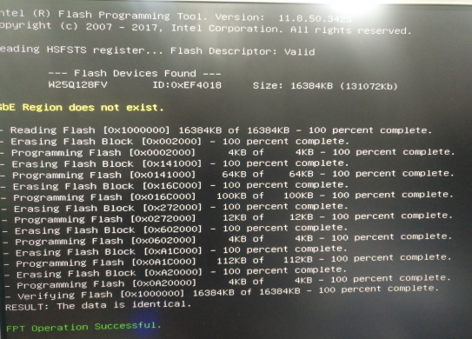

b. EC update is successful as  following:

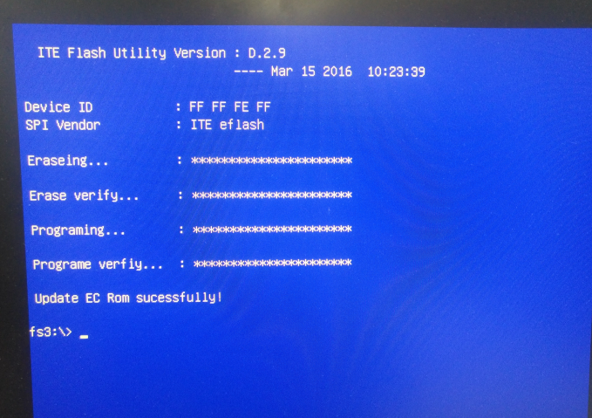

六. Pressing ”ctrl+alt+del” to reset the devices;